Wylie East High School
Football Parent Meeting Letter
2025-2026

Introduction:

We would first like to welcome all HS student-athletes to Wylie East Football. We look forward to working with your young athletes throughout the school year in preparing them for high school and life after school. It is our hope that it will be a positive, fun, and meaningful experience. Our goal is to introduce and develop in the areas of integrity, accountability, responsibility, unselfishness, respectability, work ethic, what winning is, team building, contributing, bonding and a servitude for others. The following will be brief information about different aspects of the day-to-day normalities of being a football team.

Athletics at Wylie East High School:

Being a participant in the athletic programs at Wylie East High School is considered a “Privilege”. We will hold student-athletes to higher expectations both in athletics and outside of the athletic arena. Student-athletes are expected to remain in good standing in regard to academic and behavioral expectations throughout the school year. It is our hope that all athletes will demonstrate the ability to meet these guidelines and thus maintain the privilege of being a member of our athletic program.

Communications:

We will be using SportsYou App as our main method of communication for Football. To sign up you will need to download the SportsYou App. Once you have downloaded the app, your son will receive a code in the future to enroll in the Wylie East Football team (ex. Wylie East Freshman, JV, or Varsity).
Updates, info, and day to day news can also be found on our social media sites under Facebook – Wylie East Raider Football & Twitter/Instagram - @WERaiderFB

Football Staff:

Marcus Gold - Head Football Coach (goldm@wylieisd.net)
Jerry Gardner – Offensive Coord. /Academic Assistant (gardnerj@wylieisd.net)
Jacob Merriman – Defensive Coord. & Strength & Conditioning (merrimanj@wylieisd.net)
Jay Rose – Varsity WRs/Assistant Head Coach/Recruiting Coord. (rosej@wylieisd.net)
Alex De La Torre – Co Defensive Coord. / Varsity Linebackers
Jordan Wyatt – Special Teams Coord. / Varsity Defensive Backs
Tate Rhodes – Varsity Defensive Safeties
Matt Tietjen – Varsity Running Backs
Nick Jackson – Varsity Offensive Line
Kenneth Walker – Varsity Receivers
TJ Davis – Varsity Defensive Line
BJ Smith – Head Freshman Coach (bj.smith@wylieisd.net)
John Maxwell – Freshman Assistant
Justin Bailey – Freshman Assistant
John maxwell - Freshman Assistant
Matt Langer – Freshman Assistant

Gabi Rayas – Athletic Trainer (Gabi.Fernandez@wylieisd.net)
Hannah Fitch – Athletic trainer (Hannah.Fitch@wylieisd.net)

Main Office phone number: 972-429-3150
Boy’s Athletic office phone number: 972-429-5625
Athletic Trainer’s office phone number: 972-429-5618

Locker Rooms:

The purpose of the locker room is to act as a transition area where athletes can quickly change into and out of athletic equipment. It is not a social area and players will have a set time frame to dress and undress. To begin the year, football athletes will be assigned a permanent locker. ALL football athletes will be required to take all personal items home each day for cleaning. Any personal equipment will need to be brought back to school each day for use. All athletes will have a specific time and location to meet before school to store equipment in lockers. If the athlete fails to meet at that specific time they will have to carry their equipment with them until the athletic period. It is recommended that athletes have some type of easy to carry travel bag to store their belongings for the day.

Athletic Trainers:

We will have an athletic trainer assigned to the high school campus to help monitor all sport practices. Injuries will be evaluated, and student-athletes will receive instructions for appropriate therapies or recommendations. Not every injury will require a call to the parent, but most of the time contact will be made either through email or phone. The following are some reminders from the district athletic trainers:

- Complete and submit all required online paperwork ASAP.
- Valid physicals and medical history form on file with the athletic trainer.
- Student insurance claim form needs to be obtained (from the athletic trainer) and completed before taking your child to a doctor about a school sport related injury. Generally, the school insurance will come into effect after the use of your primary insurance.
- Nutrition is vital to each athlete. A solid breakfast is recommended each morning along with an adequate lunch, so each athlete has the nutrition needed for practice. A well-balanced supper is recommended.
- Hydration! Athletes need to drink water throughout the day. Be leery of the amount of sugar found in some sports drinks. When in doubt, drink water. With the heat in August and September, it is hard to drink too much water. Remember sweating causes the loss of water and sodium.
- If you do not have a regular physician, the athletic trainers can help with access to doctors who work with us.
- Doctors’ notes and evaluations are expected (or required) following appointments in order for athletic trainers and coaches to be kept up to date with the injury status.
- There is a difference between being sore and being injured. Once a school sport injury occurs, the athletic trainers will evaluate the athlete’s condition and possibly recommend what might be the next step from a treatment standpoint.
- The athletic trainer’s recommendation will be used by the school coaches in determining the athlete’s status in regard to sports participation.
- Injury rehabilitation times will be managed by the athletic trainers. Injury rehabilitation will not occur during the athletic periods or during practice times. This is done for two reasons. All athletes need to be with their sports during the period or practice (even if not able to participate). The second reason is that the athletic trainer needs to monitor practices during these times. You will need to work out rehabilitation times with the athletic trainer.

Equipment:

- Athletes will be financially responsible for any issued athletic equipment lost or misplaced.
- Football athletes will be provided a helmet, shoulders pads, game uniforms, practice uniforms, workout cloth & a girdle, cleats, and gloves.
- Freshman will need to purchase their own workout shirt, socks, cleats & gloves.
- All athletes have the option to purchase their own girdle.
- All equipment, locker areas, practice areas, and equipment will be sanitized every day.
- Might be a good idea for each player to carry some type of hand sanitizer in their equipment bag they bring to school with them.

Generic Football Weekly Practice Schedule Friday Game Day
Day | Time | JV / Varsity | Time | Freshman
Monday | 6:05am – 6:30  6:45am – 8:20  12:00pm – 12:35  4:30pm – 5:00 | Varsity Weights / JV Walk-Thru  Varsity Practice (19 Per.)  Special Teams / JV Practice  Staff Meetings | 12:00pm – 12:30  4:45pm – 6:15 | Weights  Practice
Tuesday | 6:05am – 6:30  6:45am – 8:20  12:00pm – 12:35  4:30pm – 5:00 | ALL Meetings / JV Weights  Varsity Practice (19 Per.)  Special Teams / JV Practice  Staff Meetings | 12:00pm – 12:30  4:45pm – 6:15 | Special Teams  Practice
Wednesday | 6:05am – 6:45  7:00am – 8:20  12:00pm – 12:35 | Meetings / Walk-Thru  Varsity Practice (16 Per.)  Weights / JV Practice | 12:00pm – 1:00 | Practice
Thursday | 12:00pm – 12:35  4:30 – 5:00 | Kick The Field, JV Pack  Word Of The Week | 12:00pm – 12:40 | Walk-Thru, Pack
Friday | 12:00pm – 12:40  7:00pm | Walk-Thru, Pack / JV Weights  Kick-Off | 12:00pm – 12:40 | Weights
- The practice model and times have been placed to maximize the coaching staff availability & tutorial time.
- All football players are expected to be at each and every before / after school practice. Missed practice will result in missed game time.
IMPORTANT SUMMER DATES

Monday, April 7th
Spring Football Parent Meeting – 6:00pm (Wylie East Cafeteria)

Wednesday, May 7th
Athletic Physicals in the Wylie East IMPAC – 4:45pm – 5:30

Weeks June 9th – June 26th & July 7th – July 24th (Mon – Thurs)
Summer Strength & Conditioning Camp
Register & for more information visit - www.performancecourse.com

August 4th – August 6th (Mon – Wed)
1st week of 2-A-Days. Workouts will begin @ 7:00am for Freshman and 6:00am for JV & Varsity. Athletes should expect to be done by 11:00am

Thursday, August 7th
First day of School. Weekly Schedule to be followed.

Saturday, August 9th
Team and Individual pictures. Time: 7:00am/12:00pm Location: Wylie East HS

Thursday, August 21st
Meet the Raiders Following Varsity Scrimmage @ Wylie ISD Stadium

Holidays September 1st, September 29th, and October Fall break
All teams should expect to practice. Times TBD.

Summer Strength & Conditioning
Powered by Performance Course

Wylie East High School Summer 2025

https://www.performancecourse.com/school-district/wylie-isd

DUB – DEPEND UPON BROTHERS. We believe our program is at its highest success when individuals put the team first. We will provide our athletes with a team-first concept and create a foundation of core values based on integrity, leadership, servitude, and respect. Over the course of time our young men will learn to link on to one another, count on one another, believe in one another, & show accountability to one another through the most adverse situations in efforts to help one another Get On Board. Though many hours and preparational time will be spent on competition and teaching football, that will not be our top priority. Creating a culture where young men use these core values to play a game that will ultimately help them continue to become a more positive, successful, & selfless human being in our society will be our goal.
We as a program believe in these non-negotiables in what we call DUBeast LAW.
- Do Right!
- Be On Time!
- Speak the Truth!
- Respect your teammates, coaches, and the community!
These values will be preached in our day to day interaction with your son. We also believe trust is essential in our program in order to establish a relationship among coaches and teammates. Once a relationship is built then we can create the proper chemistry and substance in order to compete! We call this process DUBeast HOUSE.
- Coaches Believe in Coaches
- Coaches Believe in Players
- Players Believe in Coaches
- Players Believe in Players
Finally, we believe that our community breeds success. Champions come in all forms. We know every year that there are things that we as a team can always control in order to become a champion. Those qualities are as follow in what we call DUBeast CHAMPIONS.
- Show Great Body Language
- Give Great Effort
- Play with Class
- Play Smart
- Win!
DUB – DO U BELIEVE

Wylie East Freshman Football Information:

My name is BJ Smith and I have the honor and pleasure of being your child’s Head Freshman Football Coach. This is my Twentieth year of coaching (ranging from junior high coordinator, to freshman coordinator to varsity football). I am one of the few Alpha staff members here at Wylie East High School. Please read below to help your child’s transition smoother to Wylie East High School:

We wash all apparel, including towels that we provide. No athlete should ever bring home dirty laundry.
Each athlete needs to have a pair of tennis shoes/flats and cleats in their locker all year. They will also purchase their own workout shirt per the online store website we will provide them with at the beginning of 2-a-days if you missed the spring date purchase.

All combinations have been reset in the locker-room, please remind your child to lock up all items.
Each day we will do a hit chart, if your child is tardy, out of dress code, disruptive, no id badge, zeros in the grade book etc. they will receive OFI (Opportunity For Improvement).

It is highly encouraged athletes attend tutorials Monday-Friday before school or during power hour.
Once school starts practice will be Monday/Tuesday & after school till 6:15pm. The rest of practice time will be during the athletic period school hours. Position coaches may ask athletes to report early for film study/meetings.

See Rankonesport.com for football schedule. Download the SportsYou app.
Thank you and Go Raiders, DUB EAST
Any questions or concerns please feel free to email me at bj.smith@wylieisd.net

BJ Smith
972-429-3183

DUBeast RECRUITING 101

THREE THINGS WE CAN PROMISE YOU DURING THIS PROCESS:

- WE TAKE THIS PROCESS SERIOUS AS A STAFF
- WE WILL Be HONEST w/ BOTH YOU AND YOUR SON DURING THIS PROCESS
- WE WILL USE ALL RESOURCES TO MAKE SURE OUR ATHLETES HAVE EXPOSURE

NEW AGE OF RECRUITING - TWITTER IS A MUST – EVERY COLLEGE COACH HAS ONE

- Professional Twitter Handle: easy to find, easy to remember is the goal
- High School Name as your location
- Most recent updated Hudl Link
- Make sure you are able to receive DM’s
- Use your Real name
- Bio: GPA, SAT/ACT score, Class of …, Position, High School Spelt out, Any other teams your affiliated with, True Ht/Wt, Zip Code

*** GRADES MATTER: 3.0 IS THE GOAL, ALL B’s = 3.0 GPA***
**HIGHER GPA = LOWER SAT/ACT SCORE**

RECRUITING LETTERS / SPEAKING w/ COACHES:

- LETTERS DO NOT MEAN YOU’RE BEING RECRUITED
- HAND WRITTEN LETTERS DO
- WHEN SPEAKING w/ RECRUITERS INTERVIEW THEM BACK
- QUESTIONS TO ASK WHEN SPEAKING W/ RECRUITER:

  - TUTION COSTS
  - TOWN INFO.
  - DEGREES AVAILABLE AT UNIVERSITY
  - WHAT AM I BEING RECRUITED FOR
  - OFFENSIVE/DEFENSIVE SCHEME
  - FULL SCHOLARSHIP OR PARTICAL, GET THE NUMBERS

CONTROL WHAT YOU CAN CONTROL:

  - GOOD TEAMMATE
  - GRADES
  - ATTITUDE & MINDSET
  - BEHAVIOR IN THE BUILDING
  - ENJOY THE PROCESS

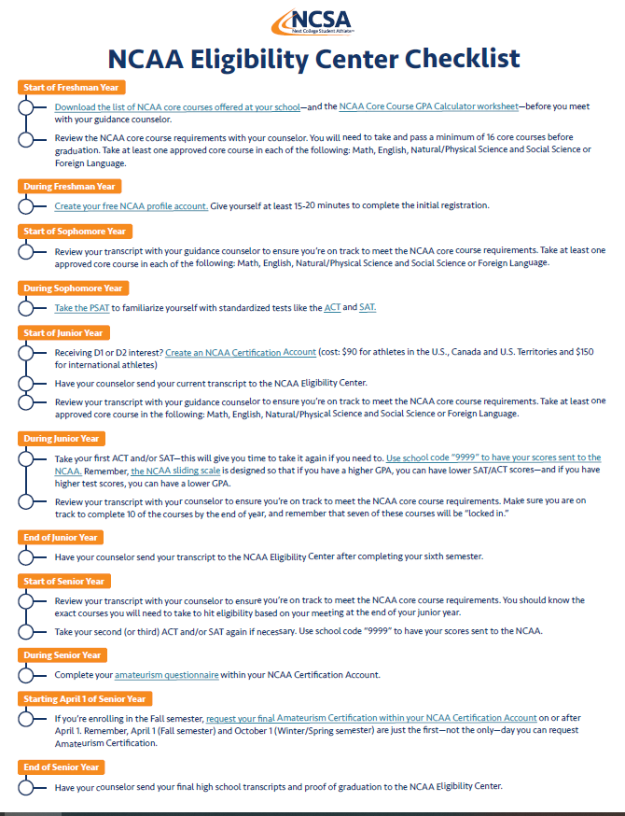

As Raider Parents, you play a HUGE role in the success of our program.
Here are 10 Guidelines that you can go by in helping our team reach its full potential!!

- Be positive with your son. Let him know he is accomplishing something by simply being a part of this team.

- If your son is not a starter, assure him that his role is extremely important to this team.

- Support your son’s coaches. They represent the authority directing this team. When the coaches are supported by the parents, the players will certainly follow suit.

- Encourage your son to follow team rules concerning drinking, curfews, discipline in the classroom, etc. We as coaches expect more from our athletes than we do the average student in the halls. The more sacrifice one makes for the team, the more that team means to him.

- Insist on your son doing his best in the classroom. Every player on our team is a valuable asset to our program.

- Parents must be team players also. Be careful not to develop envy toward other players because of statistics, etc. Parent jealousy can and will devastate a team.

- Please respect the profession of coaching. Your son’s coaches are professionals and are with your son 12 months of the year. You may want to question a coach’s decision, but to publicly slander judgments made by coaches is detrimental to the team.

- Be an enthusiastic RAIDER fan. Always display our pride with class for which we are known. Degrading of any players is not representative of the RAIDER tradition.

- Expect your son to take responsibility for his and his team’s actions. Give him the credit when things go well. But, also, hold him responsible when mistakes are made. We can learn from our mistakes only when we are held responsible.

- Strive to understand the importance of the “team.” You as parents are a vital part of our team. When the coaches, players, and parents are all believing in each other and supporting each other, all things are possible.

THANK YOU AND WE LOOK FORWARD TO A GREAT 2025 SEASON!!

